**Project 1**

1. **实验要求**

**实验一要求**

排序n个元素，元素为随机生成的长为1..32的字符串（字符串均为英文小写字母），n的取值为：22，25，28，211，214，217。

算法：直接插入排序，堆排序，归并排序，快速排序。

**实验二要求**

排序n个元素，元素为随机生成的1到65535之间的整数，n的取值为： 22，25，28，211，214，217

冒泡排序，快速排序，基数排序，计数排序。

1. **实验环境**

编译环境：

* TDM-GCC 4.9(Windows)

注：本实验用到的high_resolution_clock函数在windows下实现的很不精确。故实验数据从Linux测得。

* gcc 6.3(Linux)

机器内存：16G

时钟主频：2.60GHz

1. **实验过程**

我实在不知道如何描述实验(写代码)的过程。好吧，请允许我绘声绘色地叙述一下：

写代码写代码写代码写代码，

看reference看reference看reference看reference，

编译，调bug，编译，调bug，编译，调bug，编译，调bug，

编译，运行，调bug，编译，运行，调bug，编译，运行，调bug，编译，运行，调bug，

编译，运行，查看输出，写报告。

具体的调试和修改历史可以参见git提交记录。

实验截图：

**运行输出(这是在Windows下截的图，high_resolution_clock::now()函数在Linux下实现的更精确，可以精确到个位)**

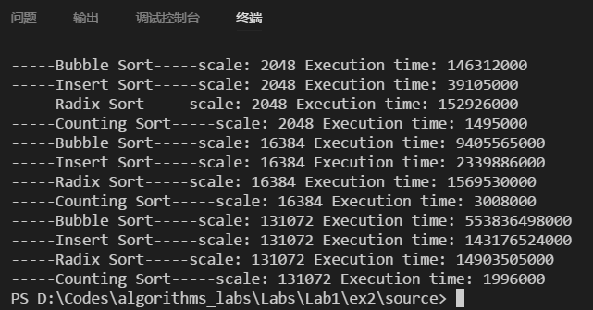

**调试场景**

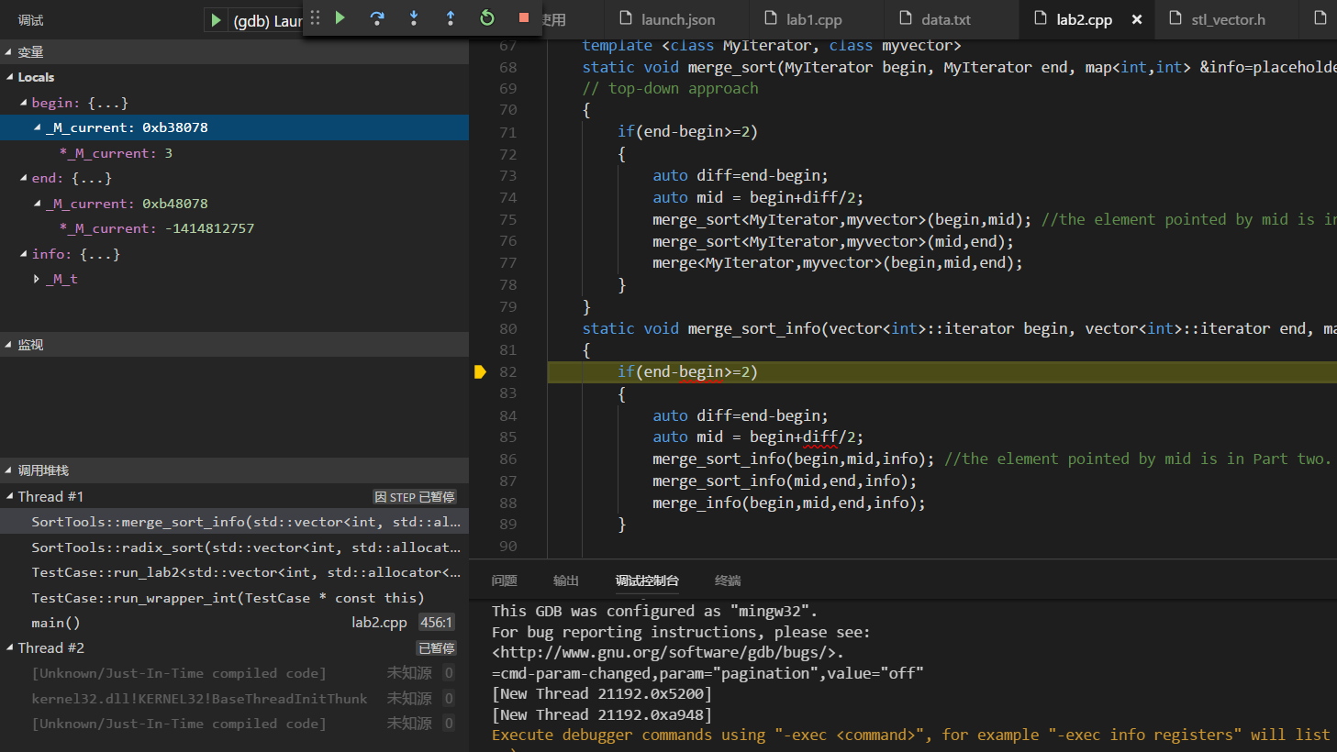

1. **编译步骤**

请在源程序目录(source)下用命令行输入：

g++ lab1.cpp -std=c++11 -O3

1. **实验设计:**

本次实验代码由C++编写。一共有两个类：SortTools, TestCase，两个随机数生成函数，和主例程。

SortTools类包含了所有的排序算法。算法均是编写成通用的template，传参类型为MyIterator的iterator类型(调用时，MyIterator可以是vector<int>::iterator和vector<string>::iterator)，同时适用于整型数和字符串。

简要介绍部分算法的设计：

基数排序radix_sort是运行多趟其他排序算法，第i趟排序中按照每个元素的第i位的大小排序。为了能够利用之前写的稳定排序算法(如merge_sort)，我将merge_sort函数的参数列表里增加了std::map &info=placeholder参数。默认该参数为placeholder，而placeholder为一不包含任何匹配的全局对象。

接着修改merge_sort函数，如果发现传参info未包含任何匹配，则照常按元素大小来排序。运行radix_sort时，调用merge_sort时传入info，此时info包含了从原元素到该元素第i位的映射，这时merge_sort会根据info里映射到的那一位的大小来排序元素。这样有效复用了原排序算法的代码，但是在radix_sort的每趟排序前，都要花时间生成info，有些低效。

每个排序算法template使用独立的函数bool compare来判断元素之间大小。而compare函数被重载：

bool compare(int a, int b); bool compare(string a, string b)

TestCase类包含了符合本实验测试流程的测试函数：

* TestCase初始化时，constructor函数会以当前时间作为随机数种子。
* run_lab1(), run_lab2()函数直接包含测试代码和计时函数。并将运行时间输出到控制台。
* run_wrapper_int()函数从数据文件读入已生成好的随机数，准备好排序前的数据结构(vector)，将此vector传入run_labi()，并接收排好序的vector。多次执行run_labi()，每次使用不同的数据规模，最后将排好序的vector输出到output文件夹。

1. **实验关键代码截图（结合文字说明）**

**Build配置文件(为自动化构建而编写的vscode config文件)**

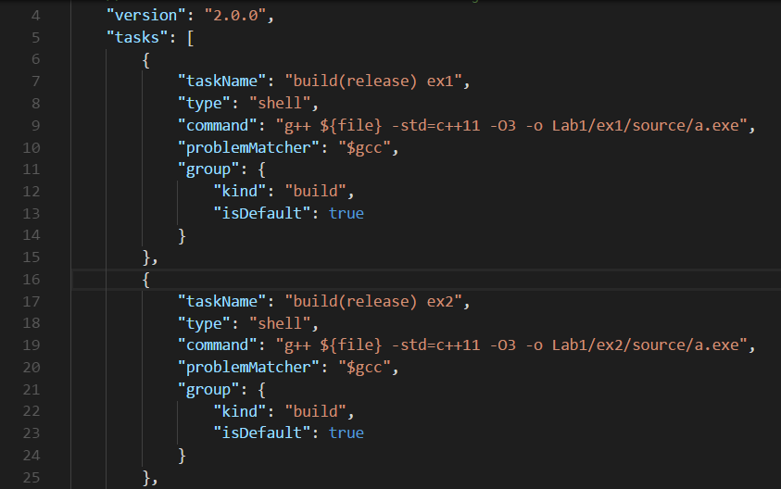

被main调用的测试程序

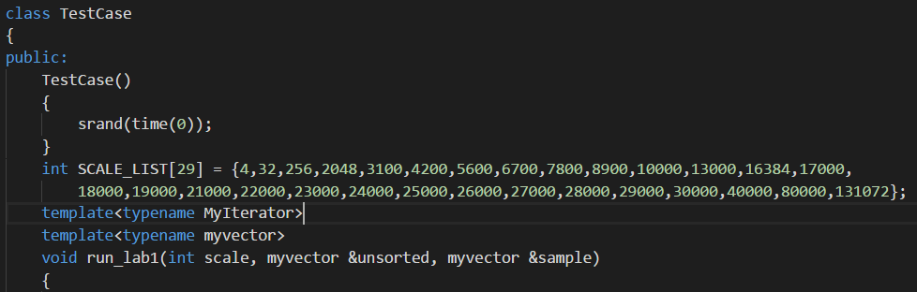

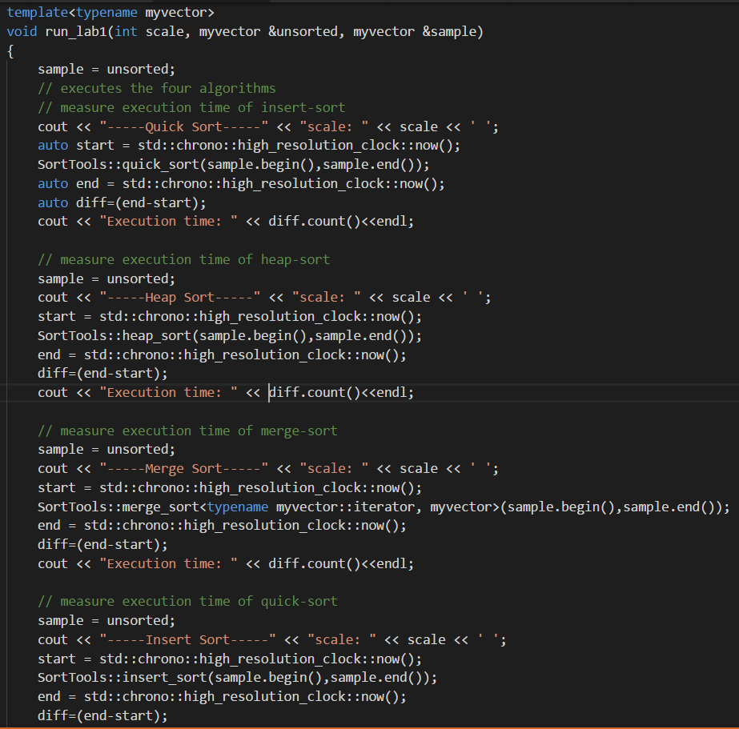

1. **数据处理**

为了使运行时间的规律更加明显，我把数据规模的个数从4个增加到了29个。并用python整理输出数据，将原C++程序输出的数据转化为Mathematica能用的数据格式。Python脚本如图所示。

(其中data_extended2.txt为C++的输出。Data_extend_sorted2.txt为python整理后的输出。)

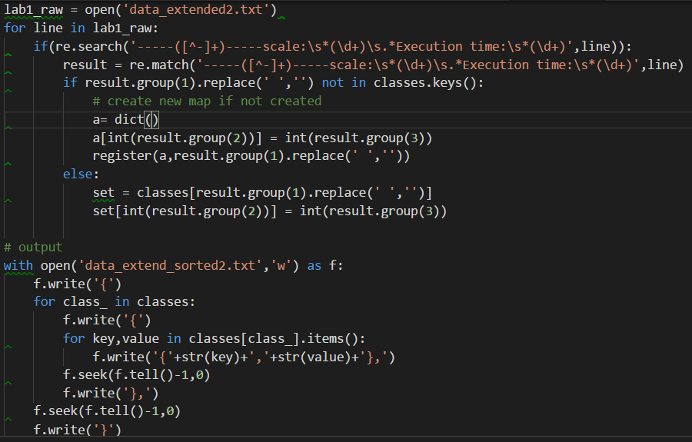

接着使用Mathematica作图：

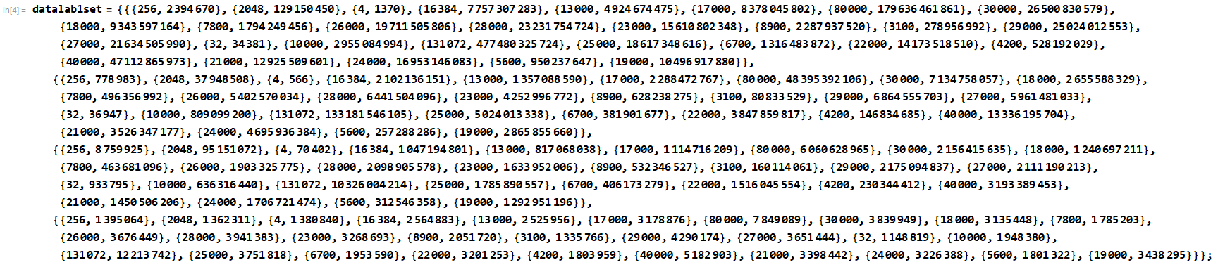

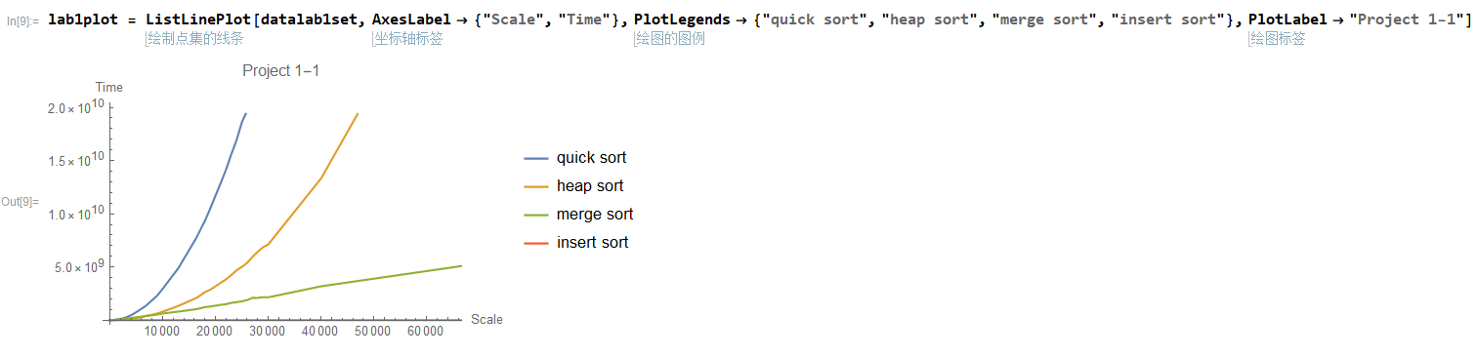

1. **实验结果、分析（结合相关数据图表分析）**

实验二数据(单位: ns)

(限于篇幅，此处仅列举前6个数据规模的结果，完整的结果列表见附录，下同)

|  |  |  |  |  |
| --- | --- | --- | --- | --- |
| 元素数量\算法 | Bubble Sort | Insert Sort | Radix Sort | Counting Sort |
| 4 | 3661 | 1616 | 111413 | 3007764 |
| 32 | 32731 | 9283 | 537374 | 1147220 |
| 256 | 2017076 | 528558 | 8031338 | 1125051 |
| 2048 | 114932653 | 33451018 | 90130295 | 1239958 |
| 16384 | 7028179025 | 1852866073 | 955585879 | 2622622 |
| 131072 | 446993869839 | 118250701430 | 9521585662 | 11836234 |

实验二分析

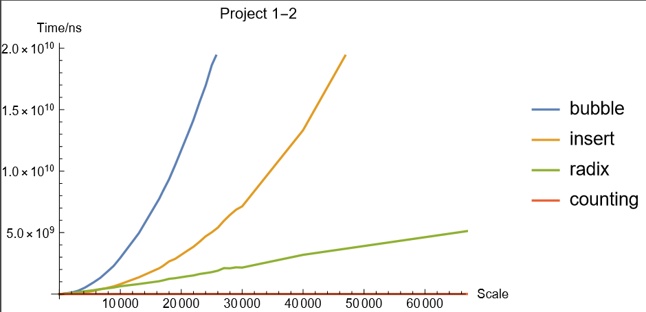

各种排序算法所耗时间的增长规律基本符合理论分析规律。

Bubble sort和insert sort均与scale的二次方同数量级，且Bubble sort的时间复杂度常数因子更大。由于不需要另外分配空间，bubble sort和insert sort在小规模数据集上的表现胜出。

Radix sort的排序时间虽然也与 $scale⋅\log{scale}$ 同数量级，但其额外开销较大，以致于在scale较小时并未显示出其优势。

Counting sort排序时间的增长速度极慢(也是与scale同数量级，在图中几乎与坐标轴重合)。一个反常现象为：在第一次运行counting sort时，其运行时间明显大于后来几次较大规模的耗时。个人推测的原因是：counting sort函数内部创建的array对象包含元素较多(六万多个)，分配内存需要时间。

实验一结果(单位：ns)

|  |  |  |  |  |
| --- | --- | --- | --- | --- |
|  | Quick Sort | Heap Sort | Merge Sort | Insert Sort |
| 4 | 4860 | 8130 | 17718 | 3095 |
| 32 | 57205 | 143505 | 277496 | 67133 |
| 256 | 437222 | 1386725 | 717148 | 913621 |
| 2048 | 1491210 | 5376369 | 7225152 | 48511257 |
| 16384 | 13917812 | 49187949 | 50922808 | 2732616574 |
| 131072 | 133368583 | 444416516 | 472809405 | 173572622734 |

实验一分析

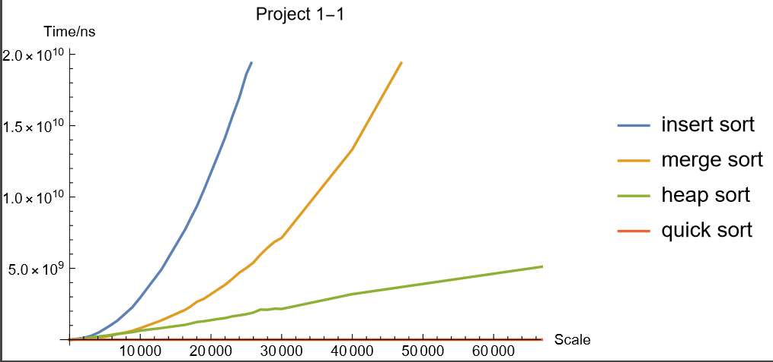

各种排序算法所耗时间的增长规律基本符合理论分析规律。

总体来看，quick sort的性能最优，而Heap-sort和merge-sort的性能不相上下。

在排序元素数量小于32时，insert sort反倒占优势，因为它不需要额外开辟存储空间。

排序元素数量大于32时，由于insert sort的比较次数较多，耗时迅速增多。

而在排序元素数量较少时，heap sort和merge sort的耗时不相上下，这可能是因为每次运行待排序元素的随机性导致的。等到排序元素增多时，两者的时间趋于一致。

1. **实验心得**

本次实验中我能更加熟练地跳出C的舒适区，编写C++程序，通过看reference初步学会了模板的使用。

我能更加熟练地配置vscode这个轻量级IDE，使用TDM-GC内置的gdb调试C++程序。

# 附录

不同规模的排序用时

Lab1-1 第一次运行

-----Bubble Sort-----scale: 4 Execution time: 3689

-----Insert Sort-----scale: 4 Execution time: 1912

-----Radix Sort-----scale: 4 Execution time: 110805

-----Counting Sort-----scale: 4 Execution time: 3128220

-----Bubble Sort-----scale: 32 Execution time: 52696

-----Insert Sort-----scale: 32 Execution time: 19839

-----Radix Sort-----scale: 32 Execution time: 871580

-----Counting Sort-----scale: 32 Execution time: 1545983

-----Bubble Sort-----scale: 256 Execution time: 2516714

-----Insert Sort-----scale: 256 Execution time: 752443

-----Radix Sort-----scale: 256 Execution time: 8791952

-----Counting Sort-----scale: 256 Execution time: 1307228

-----Bubble Sort-----scale: 2048 Execution time: 119984021

-----Insert Sort-----scale: 2048 Execution time: 32750234

-----Radix Sort-----scale: 2048 Execution time: 86428688

-----Counting Sort-----scale: 2048 Execution time: 1335087

-----Bubble Sort-----scale: 3100 Execution time: 252433907

-----Insert Sort-----scale: 3100 Execution time: 70540770

-----Radix Sort-----scale: 3100 Execution time: 145521910

-----Counting Sort-----scale: 3100 Execution time: 1434792

-----Bubble Sort-----scale: 4200 Execution time: 479185672

-----Insert Sort-----scale: 4200 Execution time: 128450784

-----Radix Sort-----scale: 4200 Execution time: 208204058

-----Counting Sort-----scale: 4200 Execution time: 1567474

-----Bubble Sort-----scale: 5600 Execution time: 835904542

-----Insert Sort-----scale: 5600 Execution time: 234286580

-----Radix Sort-----scale: 5600 Execution time: 278183080

-----Counting Sort-----scale: 5600 Execution time: 1699298

-----Bubble Sort-----scale: 6700 Execution time: 1170877362

-----Insert Sort-----scale: 6700 Execution time: 318709294

-----Radix Sort-----scale: 6700 Execution time: 339819606

-----Counting Sort-----scale: 6700 Execution time: 1916635

-----Bubble Sort-----scale: 7800 Execution time: 1613413141

-----Insert Sort-----scale: 7800 Execution time: 436678673

-----Radix Sort-----scale: 7800 Execution time: 402343203

-----Counting Sort-----scale: 7800 Execution time: 2098721

-----Bubble Sort-----scale: 8900 Execution time: 2091852625

-----Insert Sort-----scale: 8900 Execution time: 561157547

-----Radix Sort-----scale: 8900 Execution time: 471551747

-----Counting Sort-----scale: 8900 Execution time: 2100653

-----Bubble Sort-----scale: 10000 Execution time: 2675382889

-----Insert Sort-----scale: 10000 Execution time: 726064111

-----Radix Sort-----scale: 10000 Execution time: 540569497

-----Counting Sort-----scale: 10000 Execution time: 2348337

-----Bubble Sort-----scale: 13000 Execution time: 4454125064

-----Insert Sort-----scale: 13000 Execution time: 1192713143

-----Radix Sort-----scale: 13000 Execution time: 728058468

-----Counting Sort-----scale: 13000 Execution time: 2329649

-----Bubble Sort-----scale: 16384 Execution time: 7085905454

-----Insert Sort-----scale: 16384 Execution time: 1912962336

-----Radix Sort-----scale: 16384 Execution time: 951163766

-----Counting Sort-----scale: 16384 Execution time: 2912561

-----Bubble Sort-----scale: 17000 Execution time: 7679967027

-----Insert Sort-----scale: 17000 Execution time: 2055914790

-----Radix Sort-----scale: 17000 Execution time: 1002388750

-----Counting Sort-----scale: 17000 Execution time: 2658402

-----Bubble Sort-----scale: 18000 Execution time: 8486442156

-----Insert Sort-----scale: 18000 Execution time: 2298051838

-----Radix Sort-----scale: 18000 Execution time: 1065381266

-----Counting Sort-----scale: 18000 Execution time: 3005272

-----Bubble Sort-----scale: 19000 Execution time: 9574564189

-----Insert Sort-----scale: 19000 Execution time: 2669605615

-----Radix Sort-----scale: 19000 Execution time: 1146190854

-----Counting Sort-----scale: 19000 Execution time: 2929559

-----Bubble Sort-----scale: 21000 Execution time: 12299935059

-----Insert Sort-----scale: 21000 Execution time: 3362553576

-----Radix Sort-----scale: 21000 Execution time: 1386212136

-----Counting Sort-----scale: 21000 Execution time: 3339964

-----Bubble Sort-----scale: 22000 Execution time: 13254877169

-----Insert Sort-----scale: 22000 Execution time: 3550970198

-----Radix Sort-----scale: 22000 Execution time: 1388035848

-----Counting Sort-----scale: 22000 Execution time: 3056213

-----Bubble Sort-----scale: 23000 Execution time: 14493705431

-----Insert Sort-----scale: 23000 Execution time: 3948745073

-----Radix Sort-----scale: 23000 Execution time: 1498097209

-----Counting Sort-----scale: 23000 Execution time: 3240065

-----Bubble Sort-----scale: 24000 Execution time: 15596811176

-----Insert Sort-----scale: 24000 Execution time: 4186620935

-----Radix Sort-----scale: 24000 Execution time: 1615980802

-----Counting Sort-----scale: 24000 Execution time: 3415920

-----Bubble Sort-----scale: 25000 Execution time: 17897307441

-----Insert Sort-----scale: 25000 Execution time: 4966314855

-----Radix Sort-----scale: 25000 Execution time: 1775096168

-----Counting Sort-----scale: 25000 Execution time: 4630687

-----Bubble Sort-----scale: 26000 Execution time: 18613735435

-----Insert Sort-----scale: 26000 Execution time: 5220783893

-----Radix Sort-----scale: 26000 Execution time: 1728020661

-----Counting Sort-----scale: 26000 Execution time: 4047953

-----Bubble Sort-----scale: 27000 Execution time: 20278949841

-----Insert Sort-----scale: 27000 Execution time: 5614617860

-----Radix Sort-----scale: 27000 Execution time: 1877599324

-----Counting Sort-----scale: 27000 Execution time: 3551536

-----Bubble Sort-----scale: 28000 Execution time: 22036641697

-----Insert Sort-----scale: 28000 Execution time: 6083426534

-----Radix Sort-----scale: 28000 Execution time: 1971680511

-----Counting Sort-----scale: 28000 Execution time: 3970086

-----Bubble Sort-----scale: 29000 Execution time: 23795022354

-----Insert Sort-----scale: 29000 Execution time: 6423003890

-----Radix Sort-----scale: 29000 Execution time: 1959373226

-----Counting Sort-----scale: 29000 Execution time: 3975351

-----Bubble Sort-----scale: 30000 Execution time: 25630393140

-----Insert Sort-----scale: 30000 Execution time: 6762363560

-----Radix Sort-----scale: 30000 Execution time: 2031993843

-----Counting Sort-----scale: 30000 Execution time: 4101178

-----Bubble Sort-----scale: 40000 Execution time: 44719615679

-----Insert Sort-----scale: 40000 Execution time: 12203442704

-----Radix Sort-----scale: 40000 Execution time: 3024273070

-----Counting Sort-----scale: 40000 Execution time: 4819890

-----Bubble Sort-----scale: 80000 Execution time: 183036474596

-----Insert Sort-----scale: 80000 Execution time: 48880420605

-----Radix Sort-----scale: 80000 Execution time: 6642092849

-----Counting Sort-----scale: 80000 Execution time: 8716431

-----Bubble Sort-----scale: 131072 Execution time: 479762436821

-----Insert Sort-----scale: 131072 Execution time: 130244726755

-----Radix Sort-----scale: 131072 Execution time: 10145062118

-----Counting Sort-----scale: 131072 Execution time: 10809526

Lab1-1 第二次运行

-----Bubble Sort-----scale: 4 Execution time: 1370

-----Insert Sort-----scale: 4 Execution time: 566

-----Radix Sort-----scale: 4 Execution time: 70402

-----Counting Sort-----scale: 4 Execution time: 1380840

-----Bubble Sort-----scale: 32 Execution time: 34381

-----Insert Sort-----scale: 32 Execution time: 36947

-----Radix Sort-----scale: 32 Execution time: 933795

-----Counting Sort-----scale: 32 Execution time: 1148819

-----Bubble Sort-----scale: 256 Execution time: 2394670

-----Insert Sort-----scale: 256 Execution time: 778983

-----Radix Sort-----scale: 256 Execution time: 8759925

-----Counting Sort-----scale: 256 Execution time: 1395064

-----Bubble Sort-----scale: 2048 Execution time: 129150450

-----Insert Sort-----scale: 2048 Execution time: 37948508

-----Radix Sort-----scale: 2048 Execution time: 95151072

-----Counting Sort-----scale: 2048 Execution time: 1362311

-----Bubble Sort-----scale: 3100 Execution time: 278956992

-----Insert Sort-----scale: 3100 Execution time: 80833529

-----Radix Sort-----scale: 3100 Execution time: 160114061

-----Counting Sort-----scale: 3100 Execution time: 1335766

-----Bubble Sort-----scale: 4200 Execution time: 528192029

-----Insert Sort-----scale: 4200 Execution time: 146834685

-----Radix Sort-----scale: 4200 Execution time: 230344412

-----Counting Sort-----scale: 4200 Execution time: 1803959

-----Bubble Sort-----scale: 5600 Execution time: 950237647

-----Insert Sort-----scale: 5600 Execution time: 257288286

-----Radix Sort-----scale: 5600 Execution time: 312546358

-----Counting Sort-----scale: 5600 Execution time: 1801322

-----Bubble Sort-----scale: 6700 Execution time: 1316483872

-----Insert Sort-----scale: 6700 Execution time: 381901677

-----Radix Sort-----scale: 6700 Execution time: 406173279

-----Counting Sort-----scale: 6700 Execution time: 1953590

-----Bubble Sort-----scale: 7800 Execution time: 1794249456

-----Insert Sort-----scale: 7800 Execution time: 496356992

-----Radix Sort-----scale: 7800 Execution time: 463681096

-----Counting Sort-----scale: 7800 Execution time: 1785203

-----Bubble Sort-----scale: 8900 Execution time: 2287937520

-----Insert Sort-----scale: 8900 Execution time: 628238275

-----Radix Sort-----scale: 8900 Execution time: 532346527

-----Counting Sort-----scale: 8900 Execution time: 2051720

-----Bubble Sort-----scale: 10000 Execution time: 2955084994

-----Insert Sort-----scale: 10000 Execution time: 809099200

-----Radix Sort-----scale: 10000 Execution time: 636316440

-----Counting Sort-----scale: 10000 Execution time: 1948380

-----Bubble Sort-----scale: 13000 Execution time: 4924674475

-----Insert Sort-----scale: 13000 Execution time: 1357088590

-----Radix Sort-----scale: 13000 Execution time: 817068038

-----Counting Sort-----scale: 13000 Execution time: 2525956

-----Bubble Sort-----scale: 16384 Execution time: 7757307283

-----Insert Sort-----scale: 16384 Execution time: 2102136151

-----Radix Sort-----scale: 16384 Execution time: 1047194801

-----Counting Sort-----scale: 16384 Execution time: 2564883

-----Bubble Sort-----scale: 17000 Execution time: 8378045802

-----Insert Sort-----scale: 17000 Execution time: 2288472767

-----Radix Sort-----scale: 17000 Execution time: 1114716209

-----Counting Sort-----scale: 17000 Execution time: 3178876

-----Bubble Sort-----scale: 18000 Execution time: 9343597164

-----Insert Sort-----scale: 18000 Execution time: 2655588329

-----Radix Sort-----scale: 18000 Execution time: 1240697211

-----Counting Sort-----scale: 18000 Execution time: 3135448

-----Bubble Sort-----scale: 19000 Execution time: 10496917880

-----Insert Sort-----scale: 19000 Execution time: 2865855660

-----Radix Sort-----scale: 19000 Execution time: 1292951196

-----Counting Sort-----scale: 19000 Execution time: 3438295

-----Bubble Sort-----scale: 21000 Execution time: 12925509601

-----Insert Sort-----scale: 21000 Execution time: 3526347177

-----Radix Sort-----scale: 21000 Execution time: 1450506206

-----Counting Sort-----scale: 21000 Execution time: 3398442

-----Bubble Sort-----scale: 22000 Execution time: 14173518510

-----Insert Sort-----scale: 22000 Execution time: 3847859817

-----Radix Sort-----scale: 22000 Execution time: 1516045554

-----Counting Sort-----scale: 22000 Execution time: 3201253

-----Bubble Sort-----scale: 23000 Execution time: 15610802348

-----Insert Sort-----scale: 23000 Execution time: 4252996772

-----Radix Sort-----scale: 23000 Execution time: 1633952006

-----Counting Sort-----scale: 23000 Execution time: 3268693

-----Bubble Sort-----scale: 24000 Execution time: 16953146083

-----Insert Sort-----scale: 24000 Execution time: 4695936384

-----Radix Sort-----scale: 24000 Execution time: 1706721474

-----Counting Sort-----scale: 24000 Execution time: 3226388

-----Bubble Sort-----scale: 25000 Execution time: 18617348616

-----Insert Sort-----scale: 25000 Execution time: 5024013338

-----Radix Sort-----scale: 25000 Execution time: 1785890557

-----Counting Sort-----scale: 25000 Execution time: 3751818

-----Bubble Sort-----scale: 26000 Execution time: 19711505806

-----Insert Sort-----scale: 26000 Execution time: 5402570034

-----Radix Sort-----scale: 26000 Execution time: 1903325775

-----Counting Sort-----scale: 26000 Execution time: 3676449

-----Bubble Sort-----scale: 27000 Execution time: 21634505990

-----Insert Sort-----scale: 27000 Execution time: 5961481033

-----Radix Sort-----scale: 27000 Execution time: 2111190213

-----Counting Sort-----scale: 27000 Execution time: 3651444

-----Bubble Sort-----scale: 28000 Execution time: 23231754724

-----Insert Sort-----scale: 28000 Execution time: 6441504096

-----Radix Sort-----scale: 28000 Execution time: 2098905578

-----Counting Sort-----scale: 28000 Execution time: 3941383

-----Bubble Sort-----scale: 29000 Execution time: 25024012553

-----Insert Sort-----scale: 29000 Execution time: 6864555703

-----Radix Sort-----scale: 29000 Execution time: 2175094837

-----Counting Sort-----scale: 29000 Execution time: 4290174

-----Bubble Sort-----scale: 30000 Execution time: 26500830579

-----Insert Sort-----scale: 30000 Execution time: 7134758057

-----Radix Sort-----scale: 30000 Execution time: 2156415635

-----Counting Sort-----scale: 30000 Execution time: 3839949

-----Bubble Sort-----scale: 40000 Execution time: 47112865973

-----Insert Sort-----scale: 40000 Execution time: 13336195704

-----Radix Sort-----scale: 40000 Execution time: 3193389453

-----Counting Sort-----scale: 40000 Execution time: 5182903

-----Bubble Sort-----scale: 80000 Execution time: 179636461861

-----Insert Sort-----scale: 80000 Execution time: 48395392106

-----Radix Sort-----scale: 80000 Execution time: 6060628965

-----Counting Sort-----scale: 80000 Execution time: 7849089

-----Bubble Sort-----scale: 131072 Execution time: 477480325724

-----Insert Sort-----scale: 131072 Execution time: 133181546105

-----Radix Sort-----scale: 131072 Execution time: 10326004214

-----Counting Sort-----scale: 131072 Execution time: 12213742

Lab1-2 第一次运行

-----Quick Sort-----scale: 4 Execution time: 7362

-----Heap Sort-----scale: 4 Execution time: 8688

-----Merge Sort-----scale: 4 Execution time: 23697

-----Insert Sort-----scale: 4 Execution time: 3503

-----Quick Sort-----scale: 32 Execution time: 18643

-----Heap Sort-----scale: 32 Execution time: 45360

-----Merge Sort-----scale: 32 Execution time: 119667

-----Insert Sort-----scale: 32 Execution time: 21727

-----Quick Sort-----scale: 256 Execution time: 147782

-----Heap Sort-----scale: 256 Execution time: 491052

-----Merge Sort-----scale: 256 Execution time: 729919

-----Insert Sort-----scale: 256 Execution time: 858337

-----Quick Sort-----scale: 2048 Execution time: 1593549

-----Heap Sort-----scale: 2048 Execution time: 5663639

-----Merge Sort-----scale: 2048 Execution time: 6969715

-----Insert Sort-----scale: 2048 Execution time: 49238713

-----Quick Sort-----scale: 3100 Execution time: 2079805

-----Heap Sort-----scale: 3100 Execution time: 7898614

-----Merge Sort-----scale: 3100 Execution time: 11373947

-----Insert Sort-----scale: 3100 Execution time: 109052639

-----Quick Sort-----scale: 4200 Execution time: 2942369

-----Heap Sort-----scale: 4200 Execution time: 10974738

-----Merge Sort-----scale: 4200 Execution time: 16067902

-----Insert Sort-----scale: 4200 Execution time: 188239738

-----Quick Sort-----scale: 5600 Execution time: 4073656

-----Heap Sort-----scale: 5600 Execution time: 15837371

-----Merge Sort-----scale: 5600 Execution time: 19953446

-----Insert Sort-----scale: 5600 Execution time: 334071042

-----Quick Sort-----scale: 6700 Execution time: 5112025

-----Heap Sort-----scale: 6700 Execution time: 19231836

-----Merge Sort-----scale: 6700 Execution time: 25967855

-----Insert Sort-----scale: 6700 Execution time: 481669852

-----Quick Sort-----scale: 7800 Execution time: 5923376

-----Heap Sort-----scale: 7800 Execution time: 22032269

-----Merge Sort-----scale: 7800 Execution time: 27172114

-----Insert Sort-----scale: 7800 Execution time: 659394544

-----Quick Sort-----scale: 8900 Execution time: 6635550

-----Heap Sort-----scale: 8900 Execution time: 28038781

-----Merge Sort-----scale: 8900 Execution time: 35150978

-----Insert Sort-----scale: 8900 Execution time: 850800313

-----Quick Sort-----scale: 10000 Execution time: 8247291

-----Heap Sort-----scale: 10000 Execution time: 28846114

-----Merge Sort-----scale: 10000 Execution time: 38835515

-----Insert Sort-----scale: 10000 Execution time: 1059537398

-----Quick Sort-----scale: 13000 Execution time: 10543157

-----Heap Sort-----scale: 13000 Execution time: 41960354

-----Merge Sort-----scale: 13000 Execution time: 50178603

-----Insert Sort-----scale: 13000 Execution time: 1806224562

-----Quick Sort-----scale: 16384 Execution time: 13355848

-----Heap Sort-----scale: 16384 Execution time: 50119695

-----Merge Sort-----scale: 16384 Execution time: 59619625

-----Insert Sort-----scale: 16384 Execution time: 2886280680

-----Quick Sort-----scale: 17000 Execution time: 14237801

-----Heap Sort-----scale: 17000 Execution time: 50686760

-----Merge Sort-----scale: 17000 Execution time: 66094744

-----Insert Sort-----scale: 17000 Execution time: 3000661877

-----Quick Sort-----scale: 18000 Execution time: 14796736

-----Heap Sort-----scale: 18000 Execution time: 55633648

-----Merge Sort-----scale: 18000 Execution time: 72297549

-----Insert Sort-----scale: 18000 Execution time: 3466714618

-----Quick Sort-----scale: 19000 Execution time: 15745058

-----Heap Sort-----scale: 19000 Execution time: 58069400

-----Merge Sort-----scale: 19000 Execution time: 76190066

-----Insert Sort-----scale: 19000 Execution time: 3804342117

-----Quick Sort-----scale: 21000 Execution time: 18474909

-----Heap Sort-----scale: 21000 Execution time: 64806335

-----Merge Sort-----scale: 21000 Execution time: 83372338

-----Insert Sort-----scale: 21000 Execution time: 4694634757

-----Quick Sort-----scale: 22000 Execution time: 19473105

-----Heap Sort-----scale: 22000 Execution time: 65847426

-----Merge Sort-----scale: 22000 Execution time: 85296807

-----Insert Sort-----scale: 22000 Execution time: 5189973408

-----Quick Sort-----scale: 23000 Execution time: 20441703

-----Heap Sort-----scale: 23000 Execution time: 71466310

-----Merge Sort-----scale: 23000 Execution time: 90219751

-----Insert Sort-----scale: 23000 Execution time: 5737336085

-----Quick Sort-----scale: 24000 Execution time: 19961091

-----Heap Sort-----scale: 24000 Execution time: 73444720

-----Merge Sort-----scale: 24000 Execution time: 93073058

-----Insert Sort-----scale: 24000 Execution time: 6526850786

-----Quick Sort-----scale: 25000 Execution time: 22340004

-----Heap Sort-----scale: 25000 Execution time: 75740058

-----Merge Sort-----scale: 25000 Execution time: 97820381

-----Insert Sort-----scale: 25000 Execution time: 6587636359

-----Quick Sort-----scale: 26000 Execution time: 22548156

-----Heap Sort-----scale: 26000 Execution time: 81164995

-----Merge Sort-----scale: 26000 Execution time: 96491074

-----Insert Sort-----scale: 26000 Execution time: 7374443224

-----Quick Sort-----scale: 27000 Execution time: 25990904

-----Heap Sort-----scale: 27000 Execution time: 85959185

-----Merge Sort-----scale: 27000 Execution time: 112912264

-----Insert Sort-----scale: 27000 Execution time: 8173817661

-----Quick Sort-----scale: 28000 Execution time: 27614126

-----Heap Sort-----scale: 28000 Execution time: 101012007

-----Merge Sort-----scale: 28000 Execution time: 117728410

-----Insert Sort-----scale: 28000 Execution time: 8691188348

-----Quick Sort-----scale: 29000 Execution time: 25332412

-----Heap Sort-----scale: 29000 Execution time: 92205040

-----Merge Sort-----scale: 29000 Execution time: 111235176

-----Insert Sort-----scale: 29000 Execution time: 9065101356

-----Quick Sort-----scale: 30000 Execution time: 26863631

-----Heap Sort-----scale: 30000 Execution time: 91871965

-----Merge Sort-----scale: 30000 Execution time: 109143946

-----Insert Sort-----scale: 30000 Execution time: 9449817016

-----Quick Sort-----scale: 40000 Execution time: 36401477

-----Heap Sort-----scale: 40000 Execution time: 129709345

-----Merge Sort-----scale: 40000 Execution time: 167148297

-----Insert Sort-----scale: 40000 Execution time: 17240039056

-----Quick Sort-----scale: 80000 Execution time: 82488669

-----Heap Sort-----scale: 80000 Execution time: 284189496

-----Merge Sort-----scale: 80000 Execution time: 363128232

-----Insert Sort-----scale: 80000 Execution time: 69436012851

-----Quick Sort-----scale: 131072 Execution time: 136541450

-----Heap Sort-----scale: 131072 Execution time: 491314593

-----Merge Sort-----scale: 131072 Execution time: 600443077

-----Insert Sort-----scale: 131072 Execution time: 187550271793

Lab1-2 第二次运行

-----Quick Sort-----scale: 4 Execution time: 5076

-----Heap Sort-----scale: 4 Execution time: 6208

-----Merge Sort-----scale: 4 Execution time: 16625

-----Insert Sort-----scale: 4 Execution time: 2497

-----Quick Sort-----scale: 32 Execution time: 44423

-----Heap Sort-----scale: 32 Execution time: 134518

-----Merge Sort-----scale: 32 Execution time: 233689

-----Insert Sort-----scale: 32 Execution time: 53985

-----Quick Sort-----scale: 256 Execution time: 159244

-----Heap Sort-----scale: 256 Execution time: 509193

-----Merge Sort-----scale: 256 Execution time: 742947

-----Insert Sort-----scale: 256 Execution time: 912118

-----Quick Sort-----scale: 2048 Execution time: 1545283

-----Heap Sort-----scale: 2048 Execution time: 5491473

-----Merge Sort-----scale: 2048 Execution time: 6870099

-----Insert Sort-----scale: 2048 Execution time: 48833119

-----Quick Sort-----scale: 3100 Execution time: 2121045

-----Heap Sort-----scale: 3100 Execution time: 7309616

-----Merge Sort-----scale: 3100 Execution time: 12257738

-----Insert Sort-----scale: 3100 Execution time: 101509274

-----Quick Sort-----scale: 4200 Execution time: 2959634

-----Heap Sort-----scale: 4200 Execution time: 12675154

-----Merge Sort-----scale: 4200 Execution time: 17236835

-----Insert Sort-----scale: 4200 Execution time: 187192902

-----Quick Sort-----scale: 5600 Execution time: 4063713

-----Heap Sort-----scale: 5600 Execution time: 15171893

-----Merge Sort-----scale: 5600 Execution time: 20687625

-----Insert Sort-----scale: 5600 Execution time: 348547608

-----Quick Sort-----scale: 6700 Execution time: 4993772

-----Heap Sort-----scale: 6700 Execution time: 18493095

-----Merge Sort-----scale: 6700 Execution time: 24061409

-----Insert Sort-----scale: 6700 Execution time: 521764821

-----Quick Sort-----scale: 7800 Execution time: 6891297

-----Heap Sort-----scale: 7800 Execution time: 21727557

-----Merge Sort-----scale: 7800 Execution time: 30433647

-----Insert Sort-----scale: 7800 Execution time: 711181909

-----Quick Sort-----scale: 8900 Execution time: 6573026

-----Heap Sort-----scale: 8900 Execution time: 24152099

-----Merge Sort-----scale: 8900 Execution time: 32464976

-----Insert Sort-----scale: 8900 Execution time: 890040920

-----Quick Sort-----scale: 10000 Execution time: 9018098

-----Heap Sort-----scale: 10000 Execution time: 27686032

-----Merge Sort-----scale: 10000 Execution time: 37950329

-----Insert Sort-----scale: 10000 Execution time: 1143213939

-----Quick Sort-----scale: 13000 Execution time: 11143142

-----Heap Sort-----scale: 13000 Execution time: 36089720

-----Merge Sort-----scale: 13000 Execution time: 45655338

-----Insert Sort-----scale: 13000 Execution time: 1868937298

-----Quick Sort-----scale: 16384 Execution time: 15207013

-----Heap Sort-----scale: 16384 Execution time: 51384164

-----Merge Sort-----scale: 16384 Execution time: 60797139

-----Insert Sort-----scale: 16384 Execution time: 3139848852

-----Quick Sort-----scale: 17000 Execution time: 14783527

-----Heap Sort-----scale: 17000 Execution time: 50961715

-----Merge Sort-----scale: 17000 Execution time: 74490316

-----Insert Sort-----scale: 17000 Execution time: 3377128645

-----Quick Sort-----scale: 18000 Execution time: 15435833

-----Heap Sort-----scale: 18000 Execution time: 53872242

-----Merge Sort-----scale: 18000 Execution time: 70051479

-----Insert Sort-----scale: 18000 Execution time: 3678833653

-----Quick Sort-----scale: 19000 Execution time: 16455630

-----Heap Sort-----scale: 19000 Execution time: 58134123

-----Merge Sort-----scale: 19000 Execution time: 75526848

-----Insert Sort-----scale: 19000 Execution time: 4201944983

-----Quick Sort-----scale: 21000 Execution time: 18364444

-----Heap Sort-----scale: 21000 Execution time: 64023285

-----Merge Sort-----scale: 21000 Execution time: 81700783

-----Insert Sort-----scale: 21000 Execution time: 4984423716

-----Quick Sort-----scale: 22000 Execution time: 19716394

-----Heap Sort-----scale: 22000 Execution time: 65873543

-----Merge Sort-----scale: 22000 Execution time: 89878773

-----Insert Sort-----scale: 22000 Execution time: 5473581234

-----Quick Sort-----scale: 23000 Execution time: 20775397

-----Heap Sort-----scale: 23000 Execution time: 70638307

-----Merge Sort-----scale: 23000 Execution time: 87294723

-----Insert Sort-----scale: 23000 Execution time: 5910269717

-----Quick Sort-----scale: 24000 Execution time: 19957507

-----Heap Sort-----scale: 24000 Execution time: 76336237

-----Merge Sort-----scale: 24000 Execution time: 92777911

-----Insert Sort-----scale: 24000 Execution time: 6513228556

-----Quick Sort-----scale: 25000 Execution time: 22359366

-----Heap Sort-----scale: 25000 Execution time: 78919816

-----Merge Sort-----scale: 25000 Execution time: 94053506

-----Insert Sort-----scale: 25000 Execution time: 7078315174

-----Quick Sort-----scale: 26000 Execution time: 22709545

-----Heap Sort-----scale: 26000 Execution time: 81299061

-----Merge Sort-----scale: 26000 Execution time: 101346148

-----Insert Sort-----scale: 26000 Execution time: 7656405366

-----Quick Sort-----scale: 27000 Execution time: 23881168

-----Heap Sort-----scale: 27000 Execution time: 94541532

-----Merge Sort-----scale: 27000 Execution time: 123045406

-----Insert Sort-----scale: 27000 Execution time: 8325439660

-----Quick Sort-----scale: 28000 Execution time: 26061789

-----Heap Sort-----scale: 28000 Execution time: 90114619

-----Merge Sort-----scale: 28000 Execution time: 108933848

-----Insert Sort-----scale: 28000 Execution time: 8985030238

-----Quick Sort-----scale: 29000 Execution time: 25492158

-----Heap Sort-----scale: 29000 Execution time: 92572814

-----Merge Sort-----scale: 29000 Execution time: 110740899

-----Insert Sort-----scale: 29000 Execution time: 9645093611

-----Quick Sort-----scale: 30000 Execution time: 30367699

-----Heap Sort-----scale: 30000 Execution time: 99648521

-----Merge Sort-----scale: 30000 Execution time: 121254235

-----Insert Sort-----scale: 30000 Execution time: 10346638049

-----Quick Sort-----scale: 40000 Execution time: 37674328

-----Heap Sort-----scale: 40000 Execution time: 131259126

-----Merge Sort-----scale: 40000 Execution time: 168753788

-----Insert Sort-----scale: 40000 Execution time: 18362762875

-----Quick Sort-----scale: 80000 Execution time: 86417573

-----Heap Sort-----scale: 80000 Execution time: 305015044

-----Merge Sort-----scale: 80000 Execution time: 379686257

-----Insert Sort-----scale: 80000 Execution time: 74696819244

-----Quick Sort-----scale: 131072 Execution time: 140484742

-----Heap Sort-----scale: 131072 Execution time: 514314338

-----Merge Sort-----scale: 131072 Execution time: 609001716

-----Insert Sort-----scale: 131072 Execution time: 204550885326